You are cordially invited to attend


Ribbon Cutting & Open House
Date: Tuesday April 26, 2011

Time: 4:00pm - Ribbon Cutting
4:30pm -7pm Open House
(Lite Refreshments will be served)

Address: 217 Miracle Strip Parkway SE

Inside the Landmark Office Center Building ~ Historic Downtown Fort Walton Beach
RSVP ~or~ for more information: tammy@tammysjourneys.com
850-243-3809
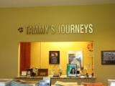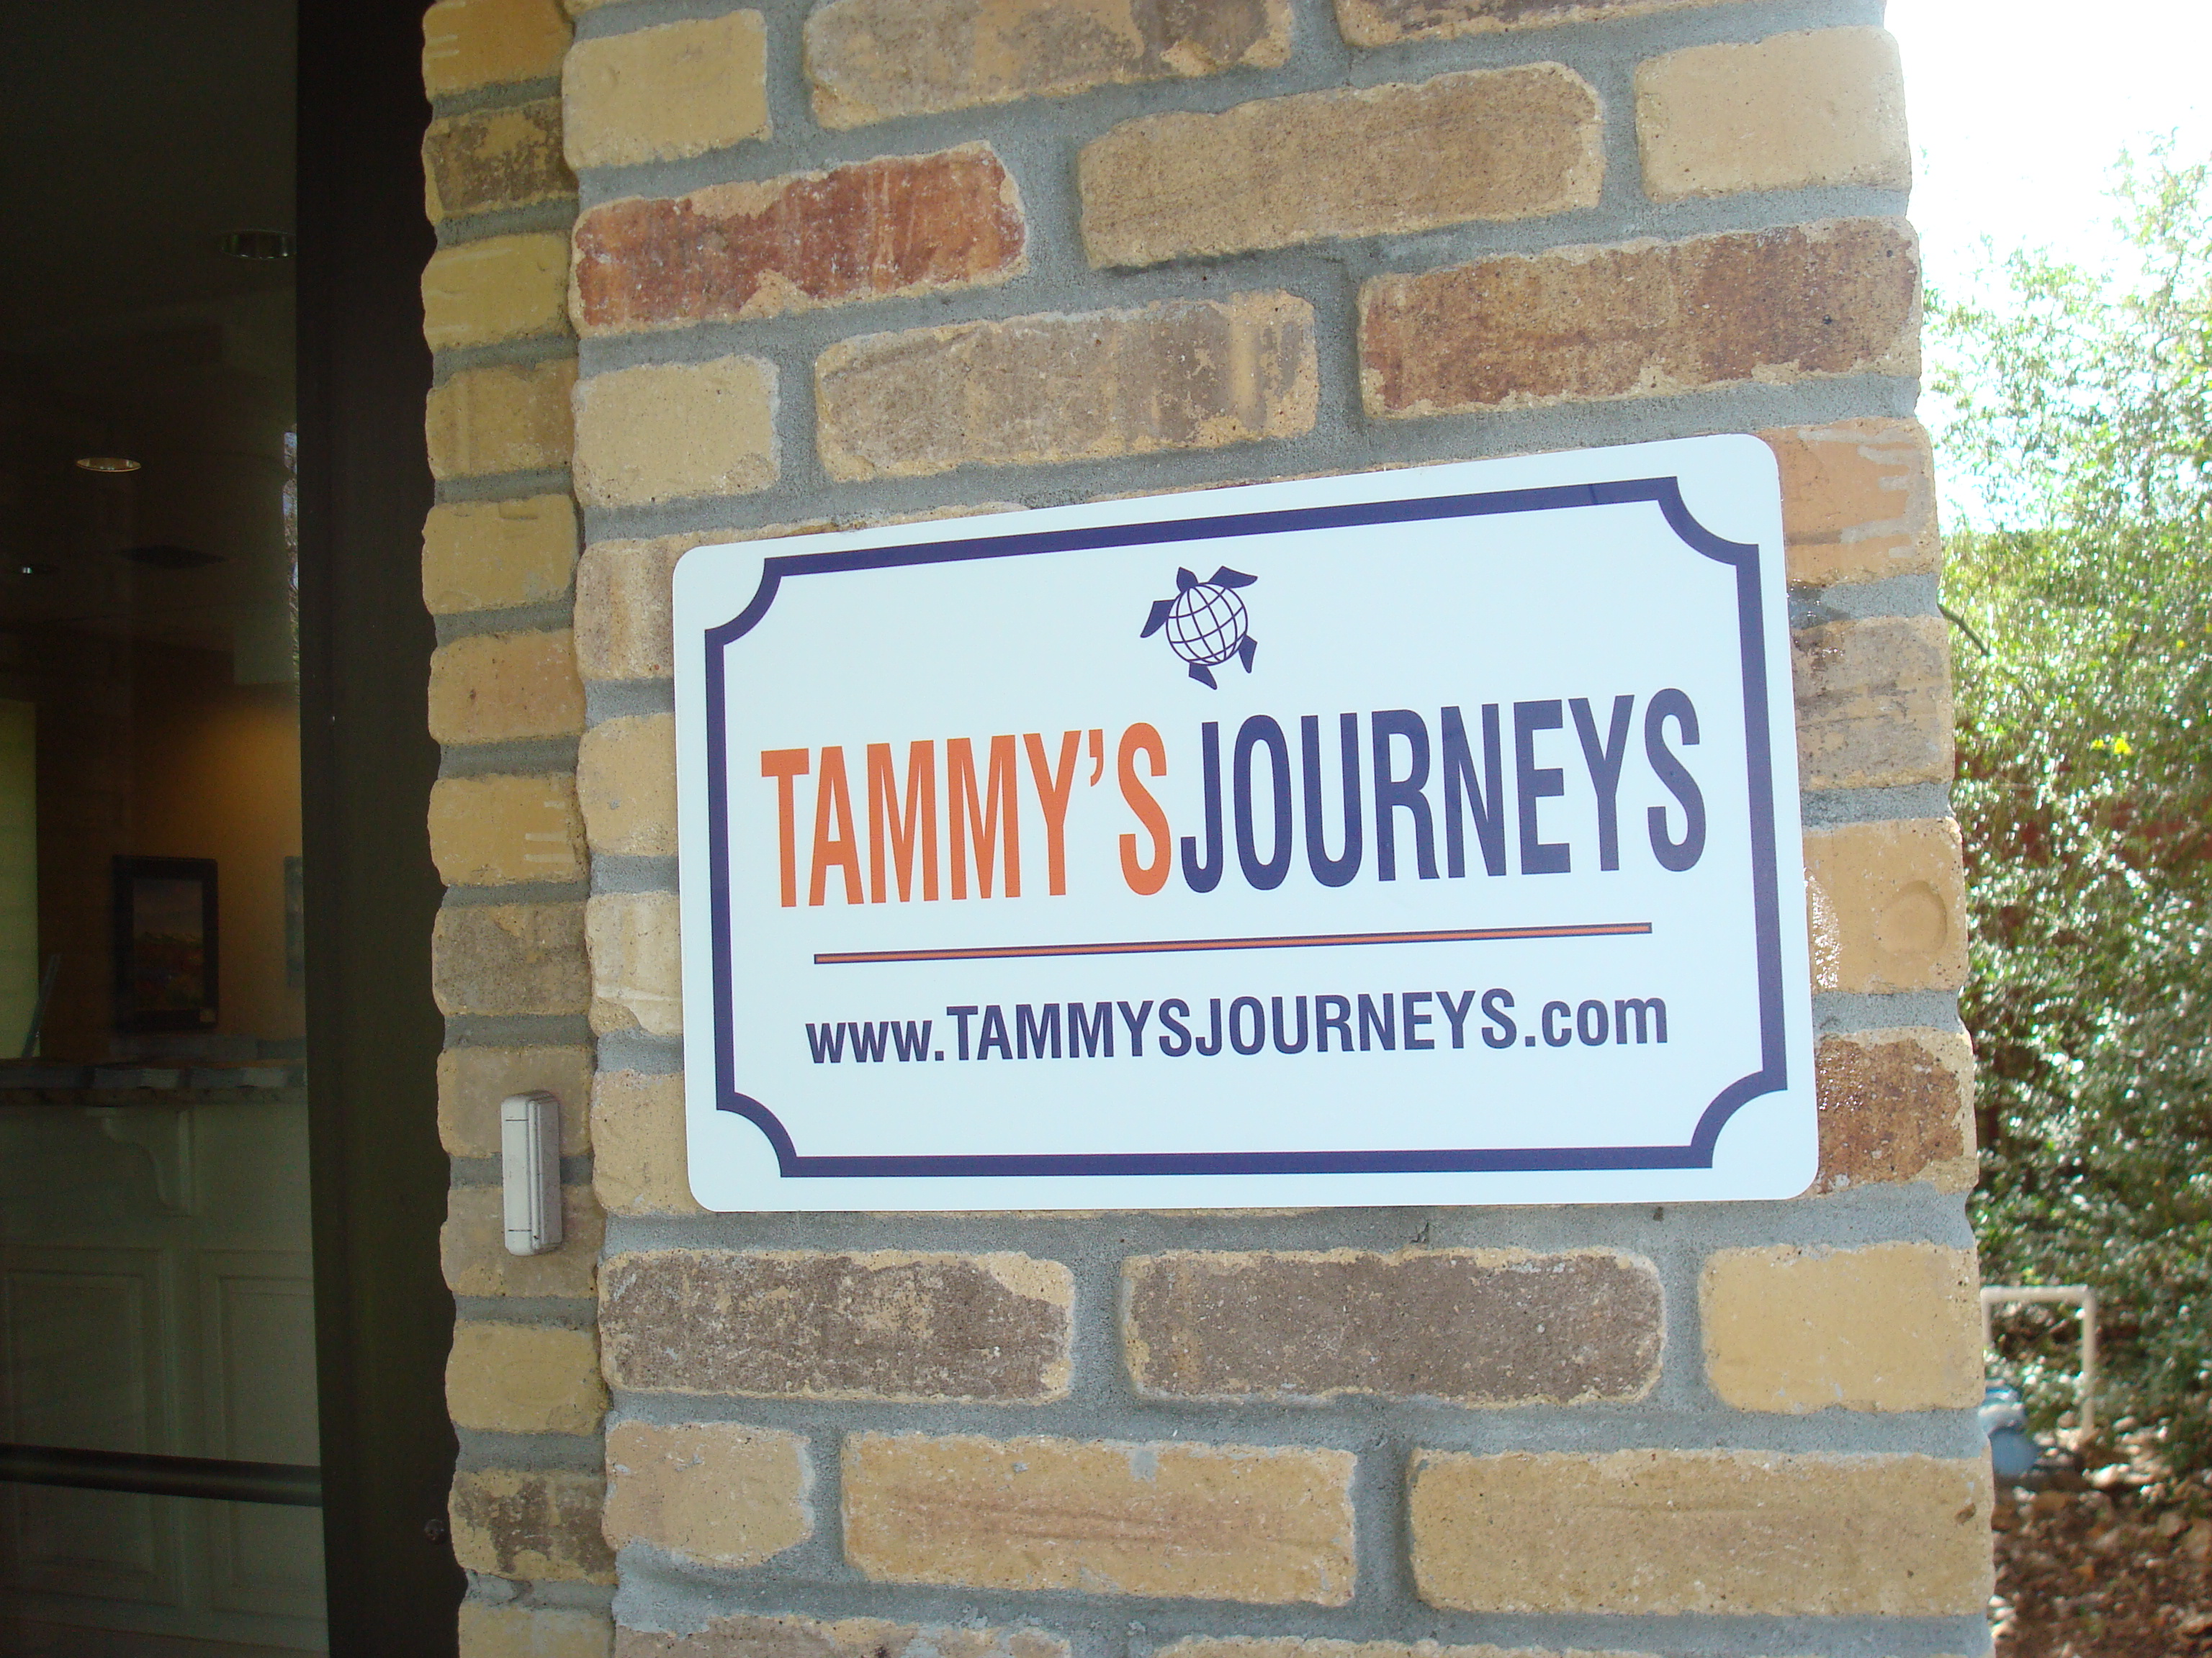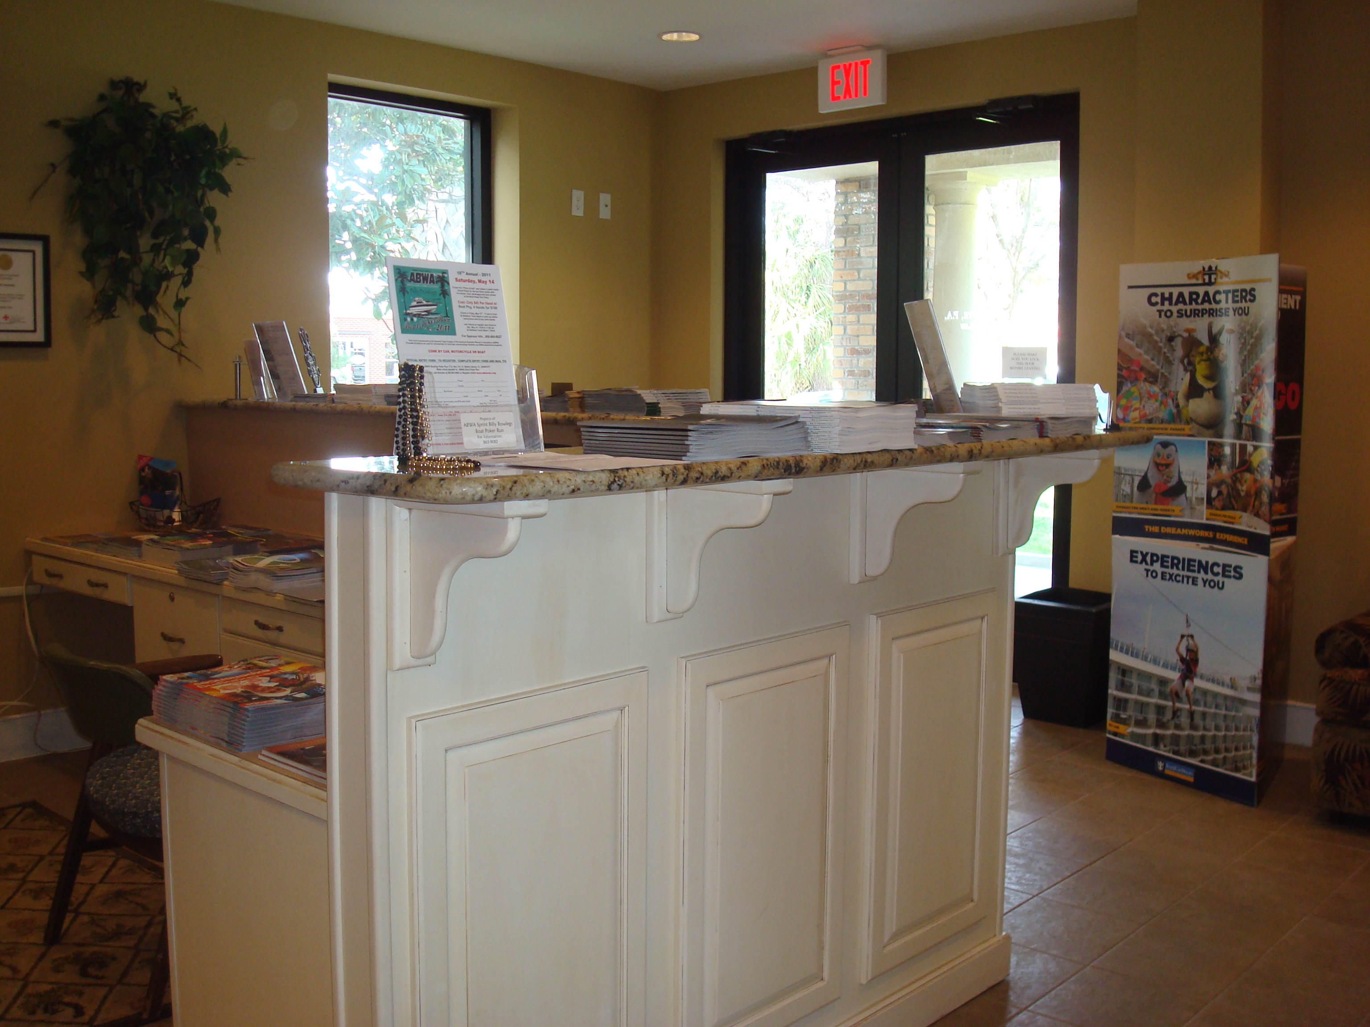
www.tammysjourneys.com
